**Texas Tech University**

**Department of Computer Science**

**Course:** Introduction to Artificial Intelligence **Group:** 1

**Student:** Felipe Chavarria Fernandez **Email:** fchavarriafernandez@gmail.com

**Date:** Friday, June 28, 2019

Table of Contents

Week 5 - Homework 5 1

Practice 1 1

Practice 2 2

Optional Problem 2b 2

Optional Problem 2c 4

Practice 3 7

# Week 5 - Homework 5

## Practice 1

Solve the normal equation by using :

W = tf.matmul(tf.matmul(tf.matrix_inverse(tf.matmul(XT, X)), XT), Y)

Where X is the train data and Y is the data labels

Next, multiply W of train data with X of test data to get predicted labels of test labels.

Print the 10 first values and compare them to the test labels:



## Practice 2

Similar to practice 1, we multiply X of test data to W and add the bias “b”

Then Compute MSE using Tensor flow

error = Y_pred - Y

mse = tf.reduce_mean(tf.square(error))

the use the optimizer and update optimizer using gradient descent and iterate over n_iterations

then run ONCE for test values using the already existent data for previous iterations using the train data. 

Then print the RMSE results:



## Optional Problem 2b

If we lower the learning rate it will take longer to converge since it is using smaller steps to get towards the global minimum and if we don’t use enough iterations it could give us a worst result since it didn’t get to the global minimum.

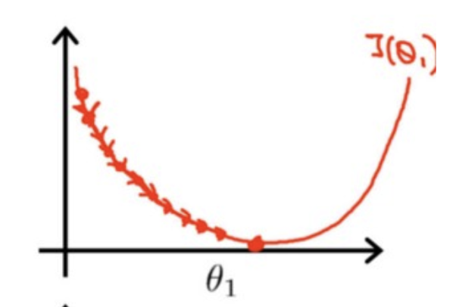

As an example, using learning_rate = 0.001 we get the following results



So here we can see that the RMSE for both test and train was worst using this learning rate

On the other hand, increasing the learning rate could get us to approach faster the global minimum but it could also overshoot to the global minimum and potentially not getting to it at all.

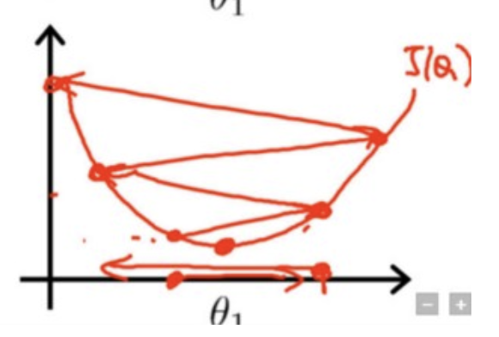

As an example, using learning_rate = 0.24 we get the following results:



We can see that comparing these results to the on in practice 2 we got to the global minimum faster with the same results so in this case we could use less iterations than needed here.

But if we continue to increase the learning rate we could potentially overshoot the global minimum and not get to it at all.

Using learning_rate = 0.25 we get the following results:



## Optional Problem 2c

learning_rate = 10

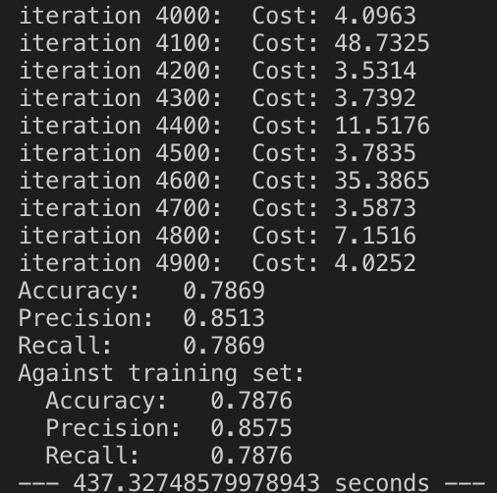

learning_rate = 20

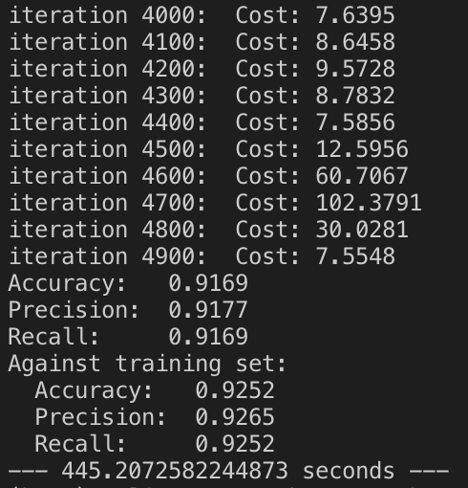

learning_rate = 30

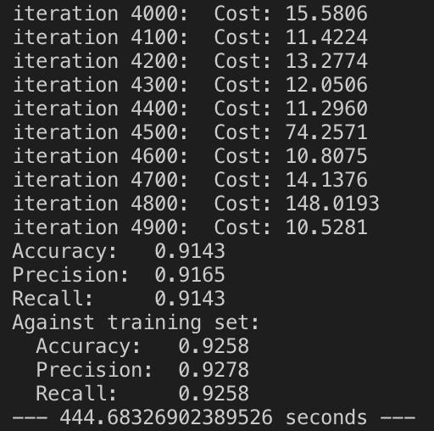

learning_rate = 40

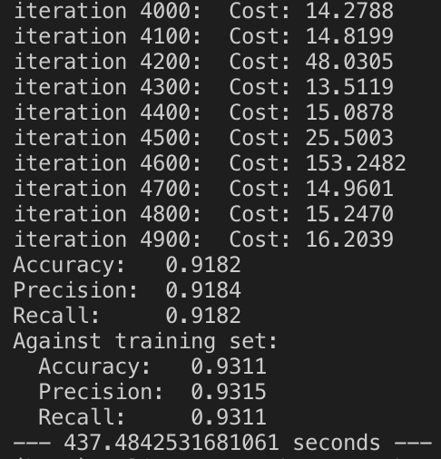

learning_rate = 60

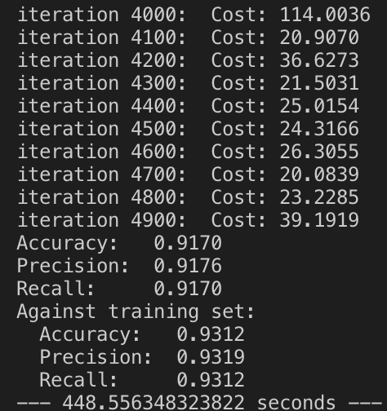

learning_rate = 100

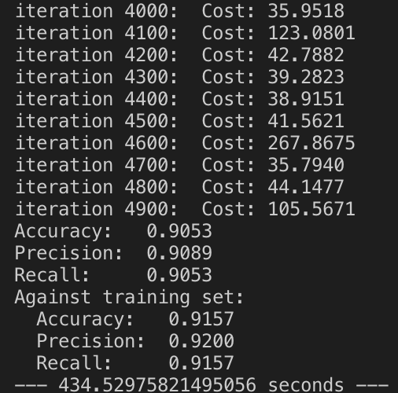

With a learning rate of 10 the accuracy, precision and recall is the worst of all, after 20 all the metrics are really similar, the best result was with a learning rate of 40 but all of them after 40 are really the same.

## Practice 3

We start creating a list to store all cost values using:

list_cost_vals.append(cost_val)

then we get the max, min an average using the following:

print("\t Min Value: ", min_epoch)

print("\t Max Value: ", max_epoch)

print("\t Average Value: ", avg_epoch)

Then we get the following values:

